**Practice-1**

**Aim:WAP to check given string is numeric or not.**

**Promgram:**

#include<iostream>

using namespace std;

int main()

{

char a[100];

int n,i,b=0,c=0;

cout << "enter the string :"<<endl ;

cin >> a ;

for(i=0; a[i]!=NULL ; i++)

{

if(a[i]>='0' && a[i]<='9')

{

b++;

}

else

{

c++;

}

}

if(b>0)

{

cout << "this is numeric string" <<endl ;

}

else

{

cout << "this is not numeric number" ;

}

return 0;

}

**Output:**

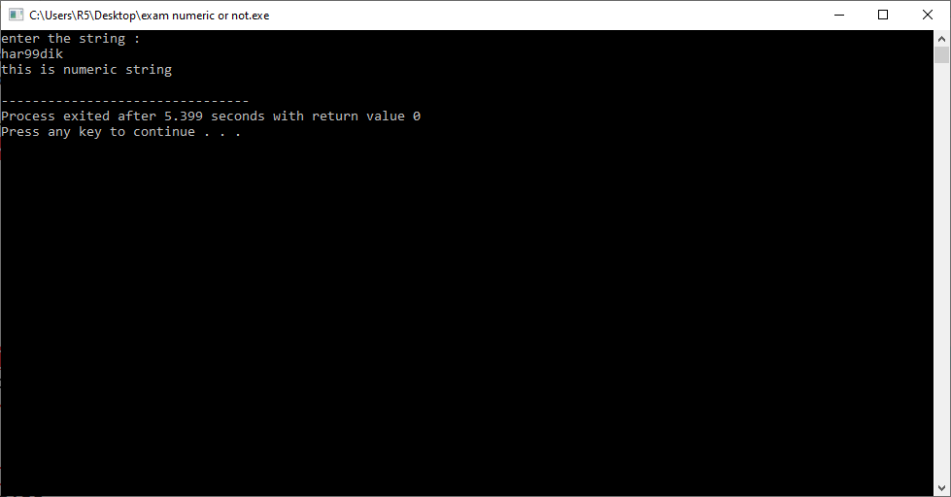

**Practice-2**

**Aim:WAP to find leap years from 2000 to 3000.**

**Promgram:**

#include<iostream>

using namespace std;

int main()

{

int year,i;

cout<<"leap year between 2000 to 3000"<<endl;

for(i=2000; i<=3000; i++)

{

if(i%4==0)

{

cout<< i <<"\t" ;

}

}

return 0;

}

**Output:**

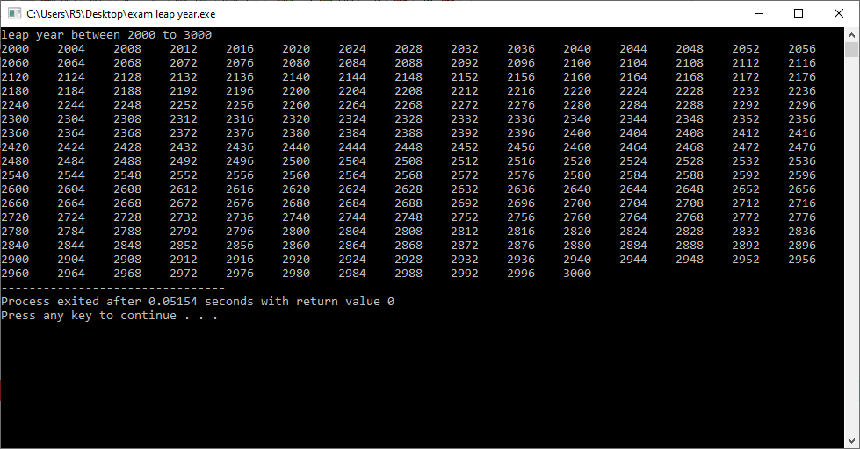

**Practice-3**

**Aim:WAP to convert given string into toggle case.**

**Promgram:**

#include<iostream>

using namespace std;

int main()

{

char a[100];

int i;

cout<<"enter the string:" << endl ;

gets(a);

for(i=0; i<=a[i]; i++)

{

if(a[i]>=65 && a[i]<=90)

{

a[i]=a[i]+32;

}

else if(a[i]>=97 && a[i]<=122)

{

a[i]=a[i]-32;

}

}

cout<< "string after covert into toggle case:" << endl ;

cout << a ;

}

**Output:**

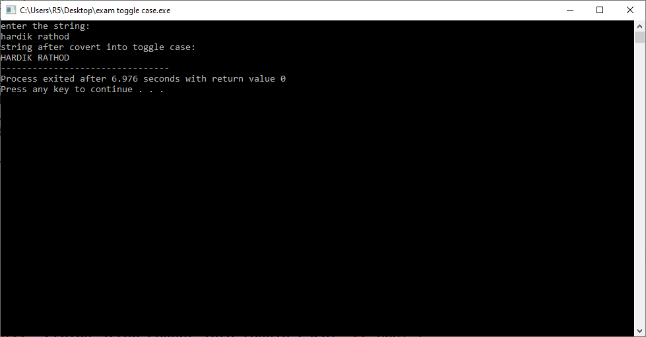

**Practice-4**

**Aim:WAP to check if a given character is vowel or consonant.**

**Promgram:**

#include<iostream>

using namespace std;

int main()

{

char n;

cout << "enter any character :" << endl ;

cin >> n ;

if(n=='a'||n=='e'||n=='i'||n=='o'||n=='u'||n=='A'||n=='E'||n=='I'||n=='O'||n=='U')

{

cout << "character is vowel" << endl ;

}

else

{

cout << "character is consonant" << endl ;

}

return 0;

}

**Output:**

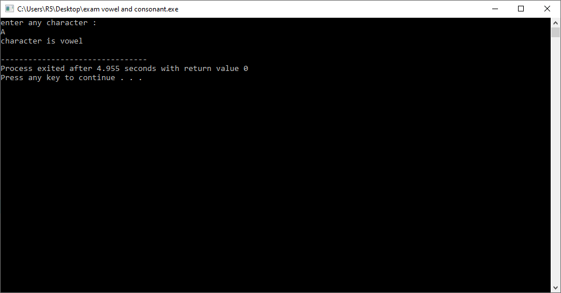

**Practice-5**

**Aim:WAP to find square root of given numbers from array elements.**

**Promgram:**

#include<iostream>

#include<math.h>

using namespace std;

int main()

{

int a[100],n,i;

float root;

cout << "enter the size of array:" << endl ;

cin >> n ;

cout << "enter element in array:"<< endl;

for(i=0; i<n; i++)

{

cin>>a[i];

}

cout<<"square root of array is :"<<endl ;

for(i=0; i<n ; i++)

{

root=sqrt(a[i]);

cout << root << endl;

}

return 0;

}

**Output:**

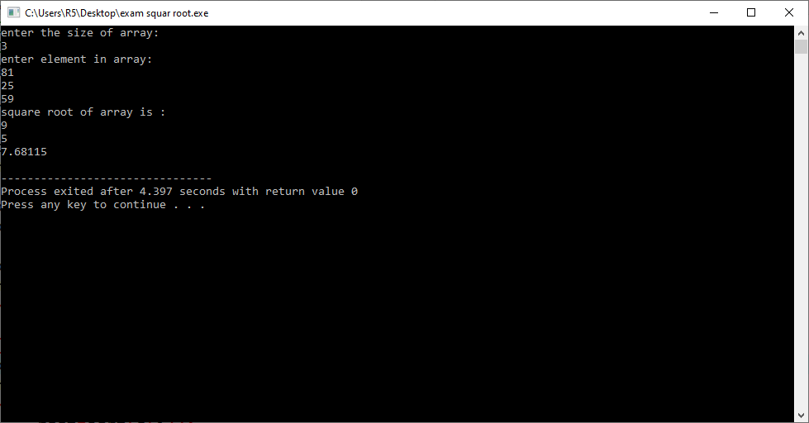

**Practice-6**

**Aim: WAP to generate cube of given 5 numbers and make an array of that generated cubes.**

**Promgram:**

#include<iostream>

#include<math.h>

using namespace std;

int main()

{

int a[5],cube,i;

cout << "enter 5 elements in array:"<< endl ;

for(i=1; i<=5; i++)

{

cin >> a[i];

}

cout << "cube of array :"<<endl ;

for(i=1; i<=5; i++)

{

cube=a[i]*a[i]*a[i];

cout << cube << endl;

}

return 0;

}

**Output:**

